AGEC 643
Homework 2
Due October 18, 2012 in Class

Use the data in HWK 2 2012.XLSX.

1. Build a simulation model to estimate the critical values of a Dickey-Fuller t-test statistic for a random walk with drift data generating process (DGP). That is, under the null hypothesis of a random walk, assume that y_{t} evolves according to

where the ε_{t} are independently identically distributed N(0,1). Use the following testing model:

Do this for two cases: once for α = 1 and once for α = 35. For both cases, estimate various percentiles of the t-test statistic distribution for sample sizes 25, 50, and 100. Use 10,000 trials for each simulation. Report the following percentiles: 0.01, 0.025, 0.05, and 0.10 in a nice table arranged like the one below. Does the value for alpha in the actual DGP influence inference for a₁?

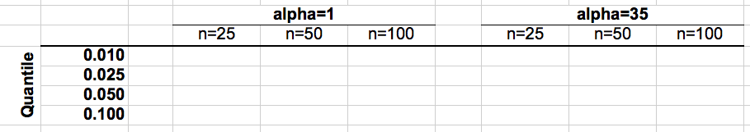

2. You are a farmer in Polk County, Iowa. You have planted 1,000 acres of corn, and have contracted with your local elevator to deliver your corn (any quantity) at $4.50 per bushel. You have total costs of $650,000. Based on your yield history, your expected yield this year is 168 bushels per acre with a standard deviation of 19 bushels. The yield distribution is presumed normal. Based on historical information, suppose that the rank correlation between your yield and total July rainfall is 0.87. In addition to corn sales, you also have a rainfall option contract that will pay you $20,000 x max(0, 2 – July rainfall), where rainfall is measured in inches. The cost of this option contract is already included in your total costs of $650,000.

Use the Iman & Conover method, along with the provided actual (non-normal looking) Polk County July rainfall history for 1948 through 2012, to characterize your profit distribution. Use N = 325 by stacking 5 copies of your historical rainfall observations. Note that you will draw all 325 yield draws simultaneously as part of the Iman & Conover calculations, and do not need to use Simetar’s simulation function. Present the following items in your answer:

- A scatter plot of yield versus July rainfall
- Simetar-fitted pdf of net profit, considering total costs, corn sales, and any option payout
- The probability of a positive profit

3. Determine the power of the Jarque-Bera test when the underlying data are distributed Cauchy with mean zero with gamma parameters of 0.5, 1, and 1.5, for sample sizes N=20, N=50, and N=100. Report the power for each combination in a table like the one below. Is the power sensitive to the sample size? Is the power sensitive to the gamma parameter?

 | Gamma=0.5 | Gamma=1 | Gamma=1.5
N=20
N=50
N=100

- Use the Macro Model data to estimate the following equations:

Domestic Qt. Demand = f ( Domestic Price X, Price of Y, Domestic Demand Shifter)

Export Qt. Demand =f( Domestic Price X, Price of Z, Export Demand Shifter)

Qt. Supply X = f( Domestic Price X, Cost of Production per Unit)

- After you estimate the three equations, assemble them into a stochastic simulation model using the std dev residuals to make the equations stochastic
- Use Solver to estimate the equilibrium price of X in deterministic mode, assuming the “Add Factors” are zero.
- Develop a table of alternative prices and resulting quantities and a line graph showing the supply and total demand lines.
- Develop a set of “Add Factors” to make the Solver deterministic equilibrium price of X equal to $16.50/unit.
- Using the “Ad Factors” in part D, simulate the macro model stochastic for 500 iterations and report the PDF for price and the simulated summary statistics for domestic demand, exports, supply, and ending stocks.

- Use the date in the Copula worksheet to simulate the 4 variable MV distribution with concordance. Simulate both the Frank and Clayton copulas and tell me which is better. Report the summary statistics for both copulas and the tests you used to indicate which is the better copula.

- Use the data in the Bootstrapper 1 worksheet and estimate the PDF for the slope coefficients and the elasticities for the exogenous variables.
- Use the data in Bootstrapper 2 to simulate the variables as a MV bootstrap distribution. Report the summary statistics for the distribution, the validations statistical tests for an MV distribution, and test the correlation matrix statistically to see if it is the same as the original data.

